How to Register/Log in
- Open your Internet Browser (Internet Explorer, Firefox, etc). Click on the following link, or copy and paste it into the web browser:
https://www.myschoolbuilding.com/myschoolbuilding/tdgateway.asp?acctNum=insert account number
- If you are a returning user, enter your Email Address and Password. Click Sign In.
- If you have forgotten your password, click the Forgot Password? Link and enter your email address. We’ll send you instructions for resetting your password.
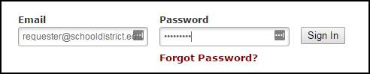
- If you are submitting your first request, you must enter registration information first. Click on the down arrow () next to Never Submitted a Request? Register Here! to expand the registration form. *Note: Your registration will be complete after you submit your first work request.
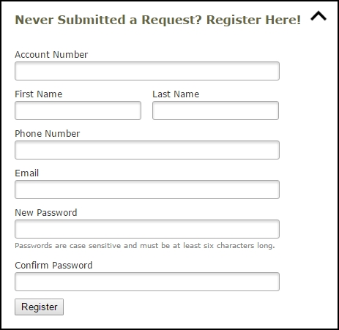
- Enter the Account Number provided by your Administrator.
- Enter your First and Last Name, as well as your Phone Number and Email Address.
- Type the Password you would like to use to log into your SchoolDude account and confirm it. The password you choose must be 6 characters long.
- Click Register to go to the work order request form.

The Dude Says:
To create a shortcut to your desktop, find a blank area on this screen and right click on your mouse. You will have the option to create a shortcut or add to your favorites. Creating a shortcut will add an icon to your desktop. You can double click it the next time you want to sign in.

How to Submit a Request
- Make sure you are on the Trip Request tab at the top of the screen.
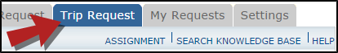
*Note: Any field marked with a red checkmark is a required field.
- The Booked By section will be filled in with your contact information according to how it was entered upon registration.
- Enter the Trip Name and the Trip Destination.
- Select your departing Location and the Organization taking the trip.
- Choose if your trip is One Way or Round Trip.
- If you are entering a frequently taken trip, you may be able to select it from the Trip Package drop down list.
- Select your trip Departure and Return Dates and Times.
- If applicable, select a Budget Code.

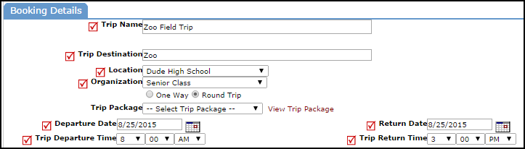

- Select the Transportation Type that is needed for your trip. Click on the icon next to the Transportation Type description to select it.

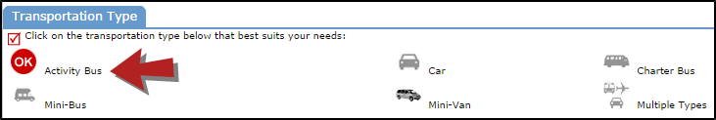
- Enter the Trip Contact. Check the box next to Yes, the 'Booked By' requester information is the same as the 'Trip Contact' information if you are going to be the contact person for the trip.
- Enter the Number of Students attending the trip.
- You can add additional information for the trip in the Faculty, Supervising Adults, Educational Objective, and Special Needs and/or Trip Requirements boxes.
  - The Educational Objectives field is a great place for additional information (such as whether multiple vehicles are needed), as it is easily seen by Administrators during the approval process
- Once the trip request form is completed, enter the submittal Password of (Insert Password).
- Click on the Submit Request button.
My Request Tab
You can view any requests that you have entered into the system by clicking on the My Requests tab. Hover your mouse over the Shortcuts link and click on My Trip Requests. You will see a listing of any requests that you have entered into the system. You are also able to print out a listing of your requests by clicking on the printer icon.
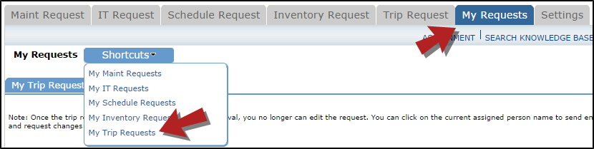
On the My Trip Requests page you will see up-to-date information on your requests including the current status, trip ID number, and total costs. You can search for any trip request by typing a key word into the Search box and clicking GO.
